**To Supply Leftover Food to Poor**

**College name** : KPR college of Arts science and research

**College code** : 19

**Team ID** :

**Team members**

Team Leader Name: Pradakshina S

Email: 23bit041@kprcas.ac.in

Team member1: Varshini S

Email: 23bit061@kprcas.ac.in

Team member2: Vasanth A

Email: 23bit062@kprcas.ac.in

Team member3: Dharani M

Email: [23bit008@kprcas.ac.in](mailto:23bit008@kprcas.ac.in)

Team member4: Barath G

Email: 23bit006@kprcas.ac.in

**Food Connect Salesforce Project Documentation**

**Project Overview**

Food Connect is a Salesforce-based application designed to manage food distribution and volunteer coordination. The project demonstrates Salesforce core features such as custom objects, relationships, flows, triggers, reports, dashboards, and sharing rules. The app helps organizations track food drop-off points, venues, volunteers, tasks, and execution details while enabling reporting and monitoring.

**1. Developer Account Setup**

Before building the application, a Salesforce Developer account is required:

* Sign up at Salesforce Developer Signup.
* Provide necessary details (Name, Email, Role = Developer, Company/College, Country = India, Pin Code, and Username in email format).
* Verify your account through email and set up password and security questions.
* This developer org serves as the environment where the Food Connect app will be developed and tested.

**2. Creating Custom Objects**

Objects represent database tables in Salesforce. For Food Connect, the following custom objects were created:

**2.1 Drop-Off Point**

* **Purpose**: Represents food collection points.
* **Key Fields**: Drop-Off Point Name (Text).
* **Settings Enabled**: Reports, Field History, Activities, Search. 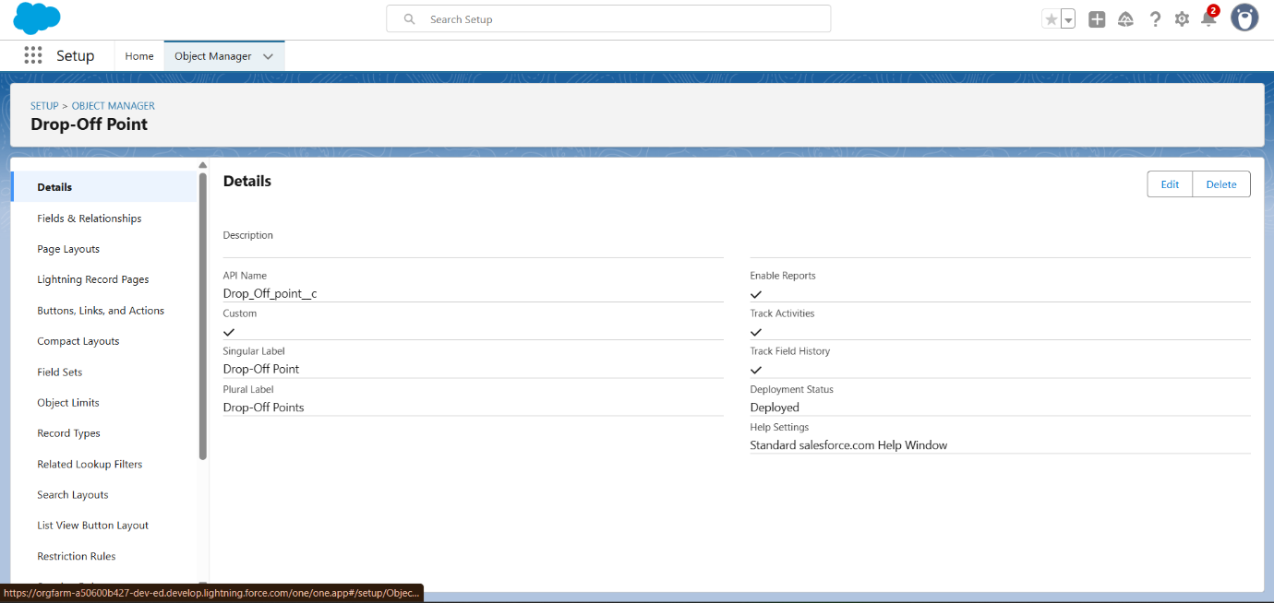

**2.2 Venue**

* **Purpose**: Represents the main distribution centres.
* **Key Fields**: Venue Name (Text).
* **Settings Enabled**: Reports, Field History, Activities, Search. 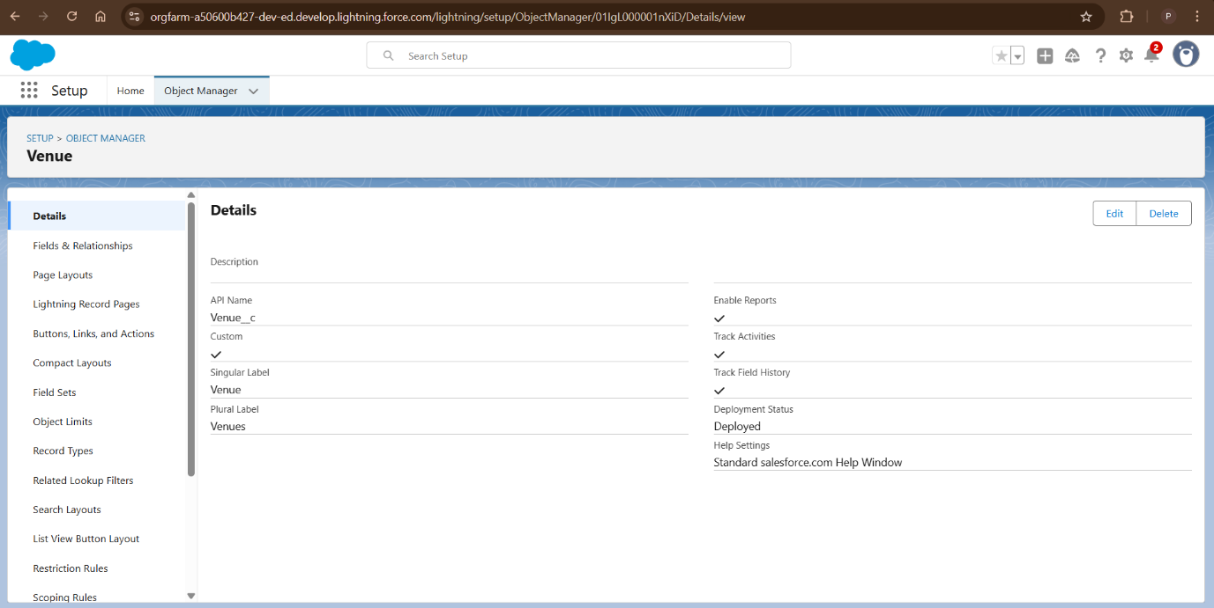

**2.3 Volunteer**

* **Purpose**: Stores volunteer information.
* **Key Fields**: Volunteer Name (Text).
* **Settings Enabled**: Reports, Field History, Activities, Search. 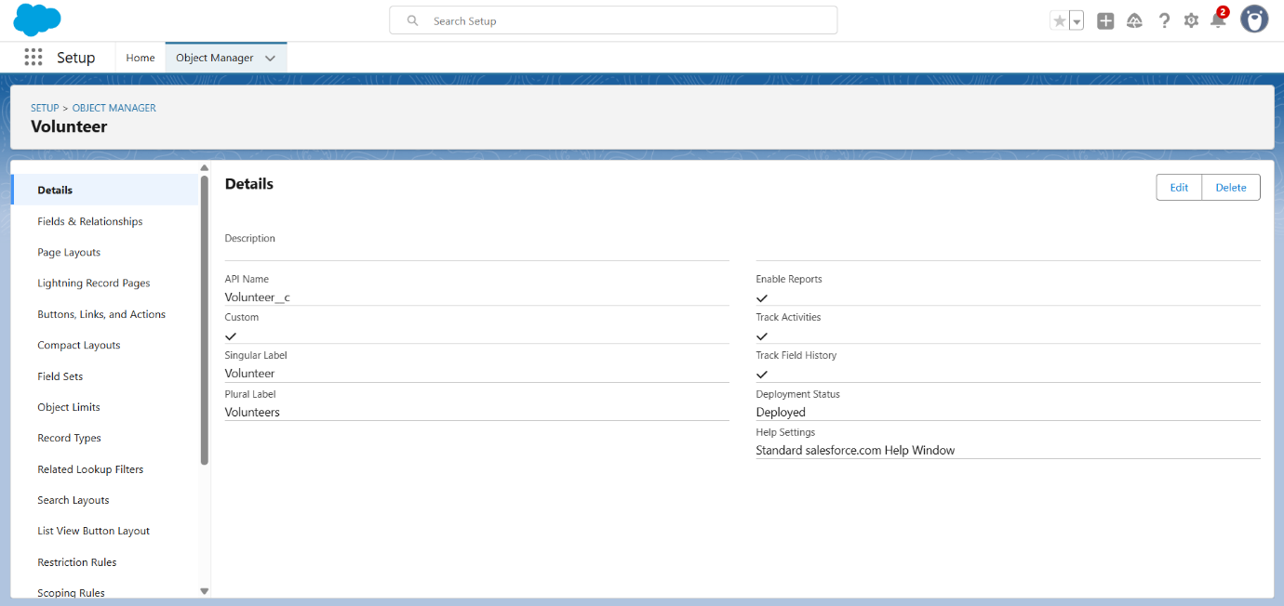

**2.4 Task**

* **Purpose**: Represents food distribution activities.
* **Key Fields**: Task Name (Text).
* **Settings Enabled**: Reports, Field History, Activities, Search. 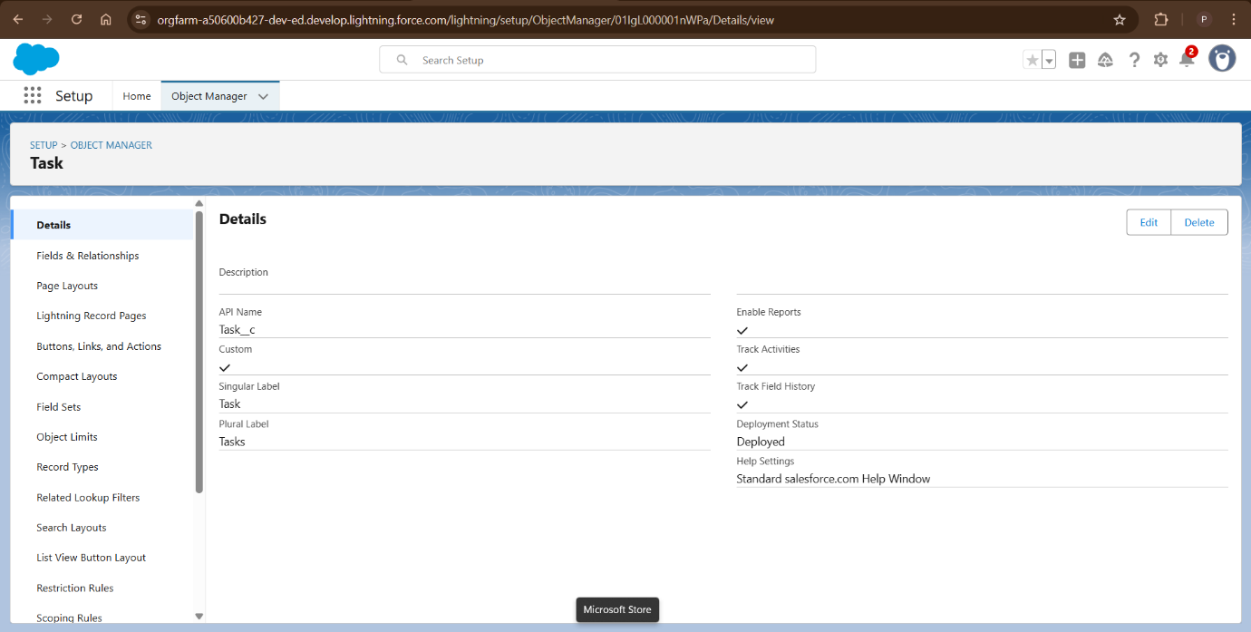

**2.5 Execution Detail**

* **Purpose**: Tracks execution details for tasks and volunteers.
* **Key Fields**: Execution Detail Name (Text).
* **Settings Enabled**: Reports, Field History, Activities, Search. 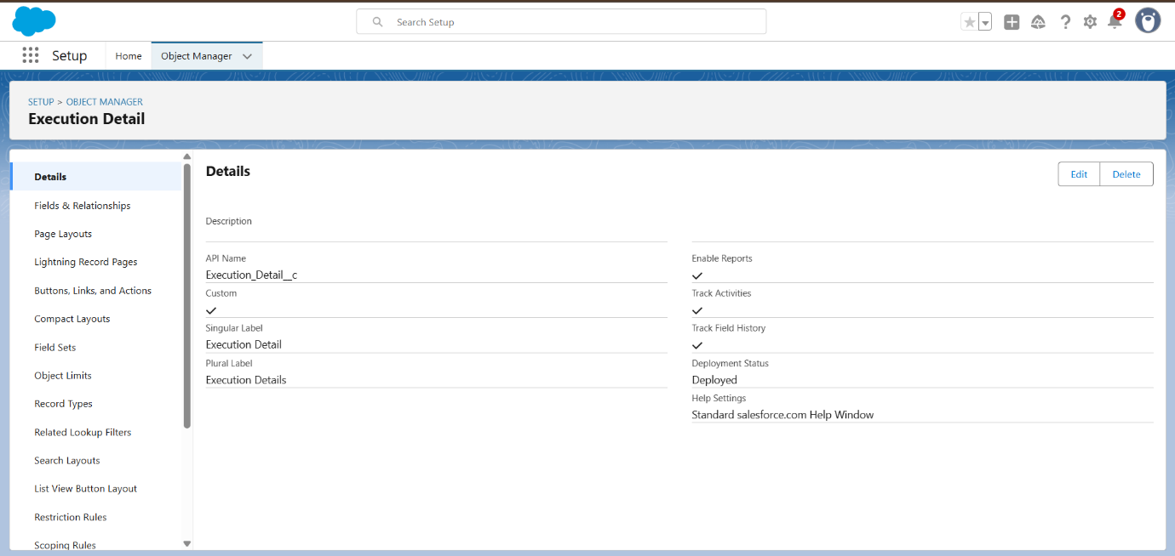

**3. Creating Tabs**

Custom tabs allow users to access objects in the app:

* Tabs created for: **Venue, Drop-Off Point, Task, Volunteer, Execution Details**.
* Setup Path: Tabs → New → Select Object → Configure Tab Style.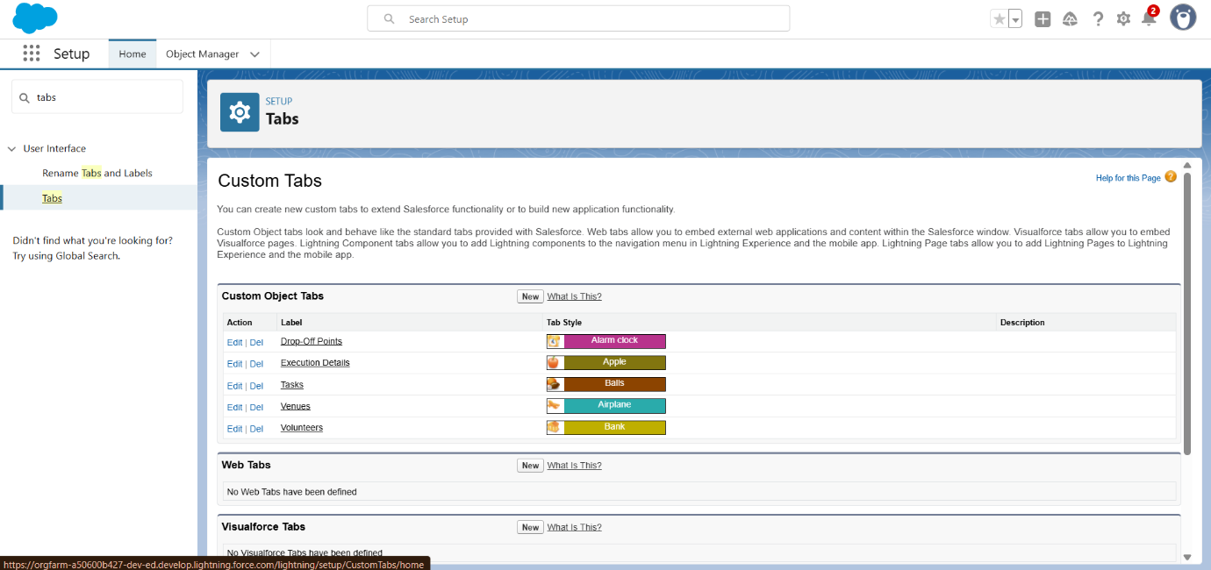

**4. Creating the Lightning App: Food Connect**

The Food Connect app provides a unified interface for all objects.

1. **Setup Path**: App Manager → New Lightning App.
2. **App Details**:
   * Name: Food Connect
   * Developer Name: Auto-generated
3. **Navigation Style**: Standard Navigation
4. **Navigation Items Added**: Home, Venue, Drop-Off Point, Task, Volunteer, Execution Details, Reports.
5. **Profiles**: Assigned to System Administrator.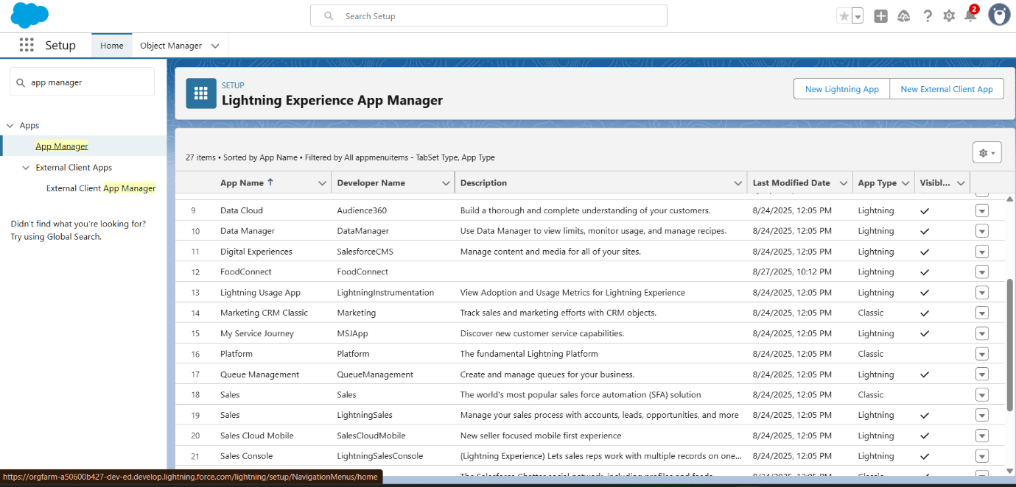

**5. Creating Relationships**

Relationships link objects together, enabling structured data flow.

* **Volunteer → Drop-Off Point**: Master-Detail
* **Execution Details → Volunteer**: Master-Detail
* **Execution Details → Task**: Master-Detail
* **Drop-Off Point → Venue**: Lookup
* **Task → Venue**: Lookup
* **Task → Drop-Off Point**: Lookup

These relationships allow reports and dashboards to show connected data across objects.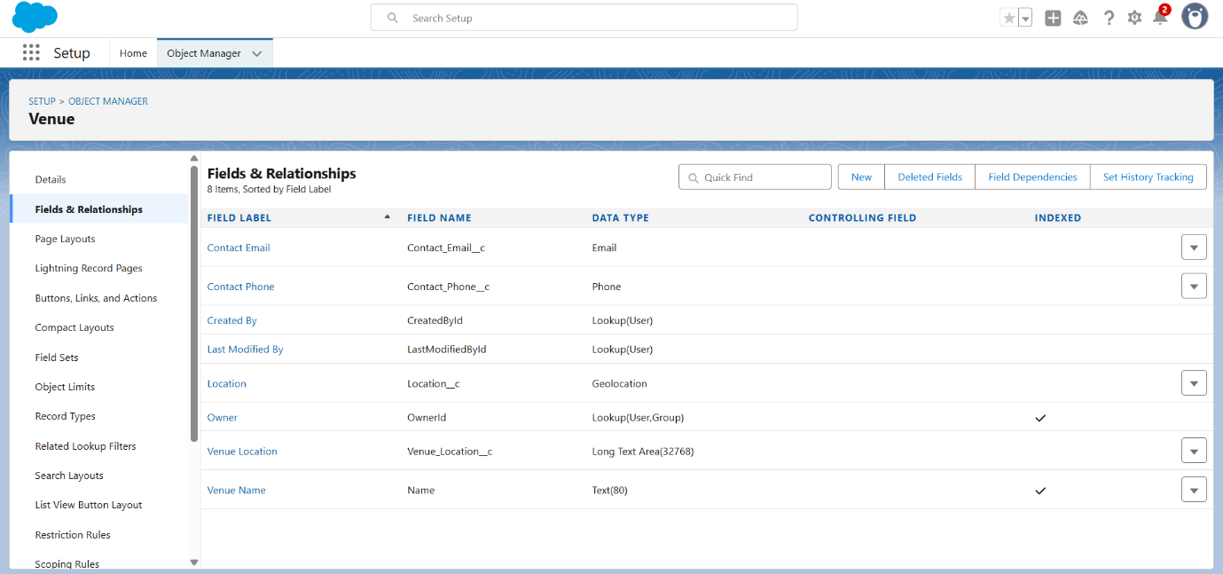

**6. Creating Fields**

Custom fields were added to capture specific information:

* **Venue**: Contact Email, Contact Phone, Location (Geolocation), Venue Location (Long Text Area).
* **Drop-Off Point**: Location 2 (Geolocation), Distance Calculation (Formula), State (Picklist).
* **Task**: Task ID (Auto Number), Date, Food Category (Multi-Select Picklist), Number of People Served, Rating, Feedback, etc.
* **Volunteer**: Volunteer ID (Auto Number), Gender (Picklist), Available On (Date), Age, Email, Address, Date of Birth.
* **Execution Detail**: Execution ID (Auto Number).

These fields enrich the data stored and provide better tracking. 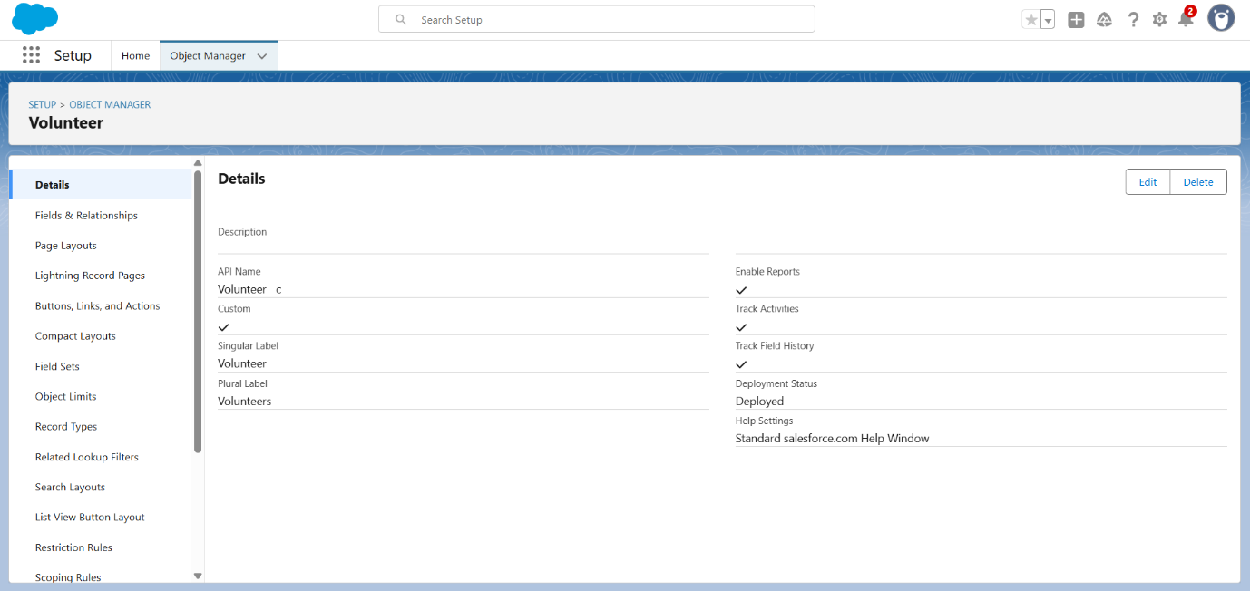

**7. Flows**

Flows automate record creation. A **Screen Flow** was created to insert Venue records:

* Fields captured: Venue Name, Contact Email, Contact Phone, Venue Location, Latitude, Longitude.
* Flow saves the input as a new Venue record.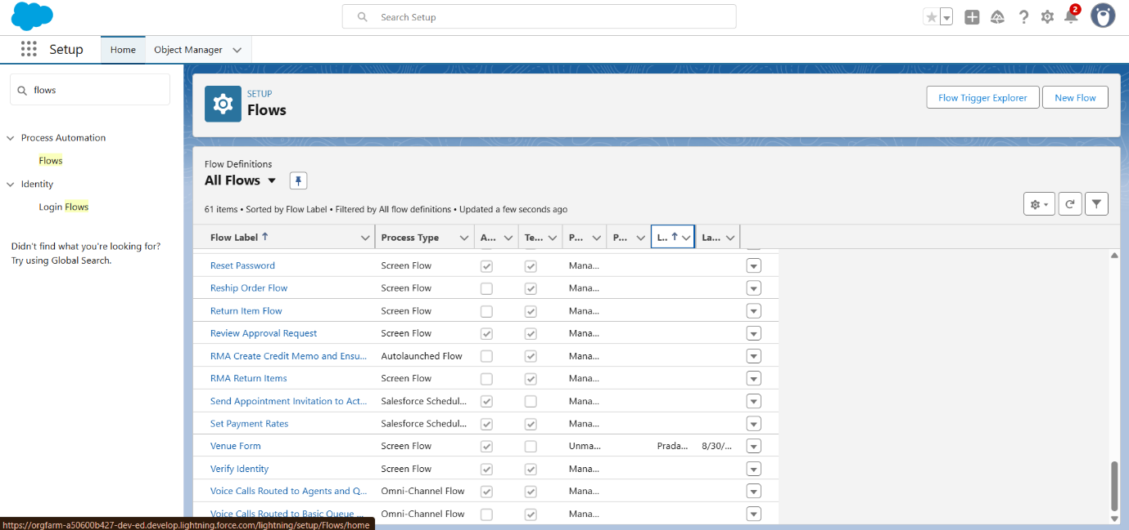

**8. Triggers**

A simple Apex Trigger was created:

* **Trigger Name**: DropOffTrigger
* **Object**: Drop-Off Point
* **Purpose**: Assign Distance field value from Distance Calculation formula.

trigger DropOffTrigger on Drop_Off_point__c (before insert) {

for(Drop_Off_point__c Drop : Trigger.new){

Drop.Distance__c = Drop.distance_calculation__c;

}

}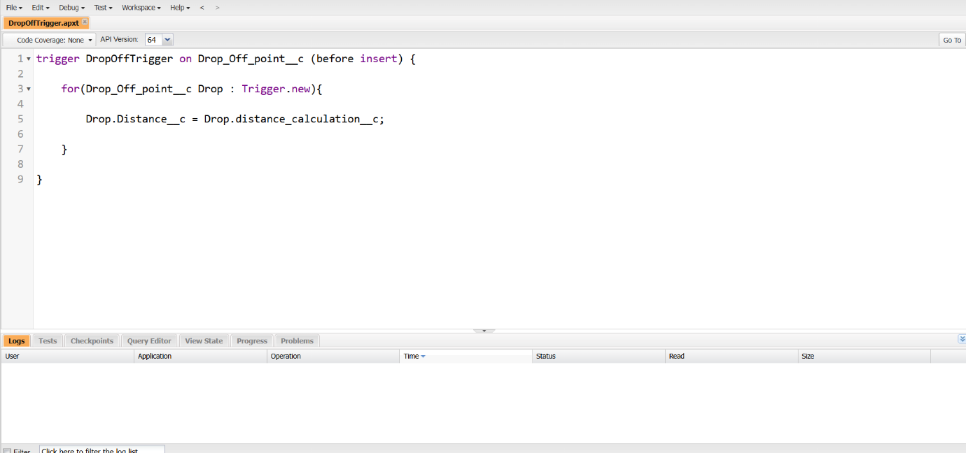

**9. Profiles, Users, and Public Groups**

* **Profile**: NGOs Profile (cloned from Standard Platform User).
* **Users**: Created 3 NGO users (Iksha Foundation, NSS, Street Cause).
* **Public Groups**: Created groups for each NGO and added relevant users.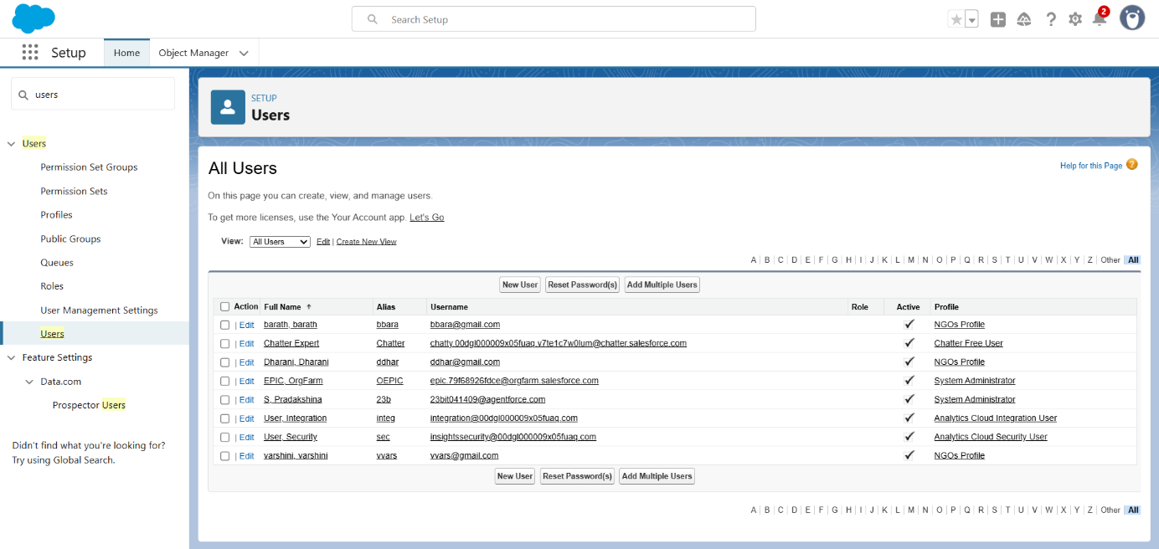
* 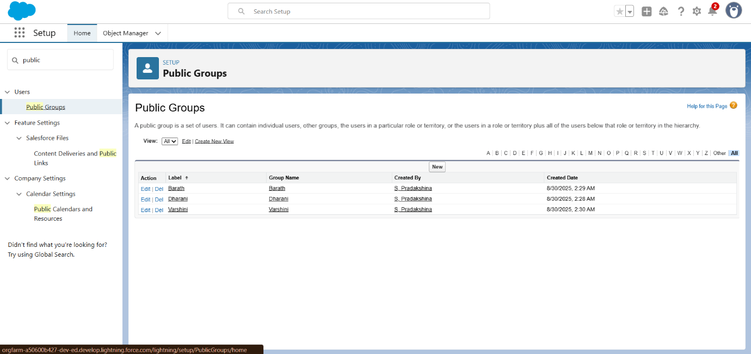

**10. Reports & Dashboards**

**Custom Report Types**

1. **Venue with Drop-Off with Volunteer**
   * Primary Object: Venue
   * Related Objects: Drop-Off Point, Volunteer
2. **Volunteers with Execution Details and Tasks**
   * Primary Object: Volunteer
   * Related Objects: Execution Details, Task

**Reports**

* **Venue and Drop-Off Point Report**: Displays Venue Name, Drop-Off Point Name, Distance.
* **Volunteer Task Report**: Displays Volunteer details with related Task and Execution Detail data.

**Dashboards**

* **Dashboard Name**: Organization Details
* Components:
  + Venue & Drop-Off Report: Lightning Table
  + Volunteer Task Report: Line Chart
  + Optional: Image upload for branding.
  + 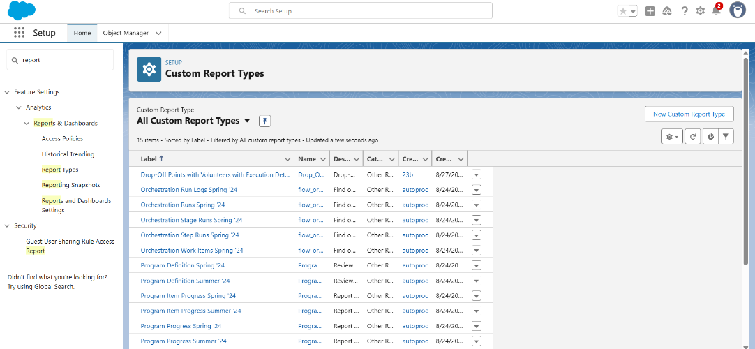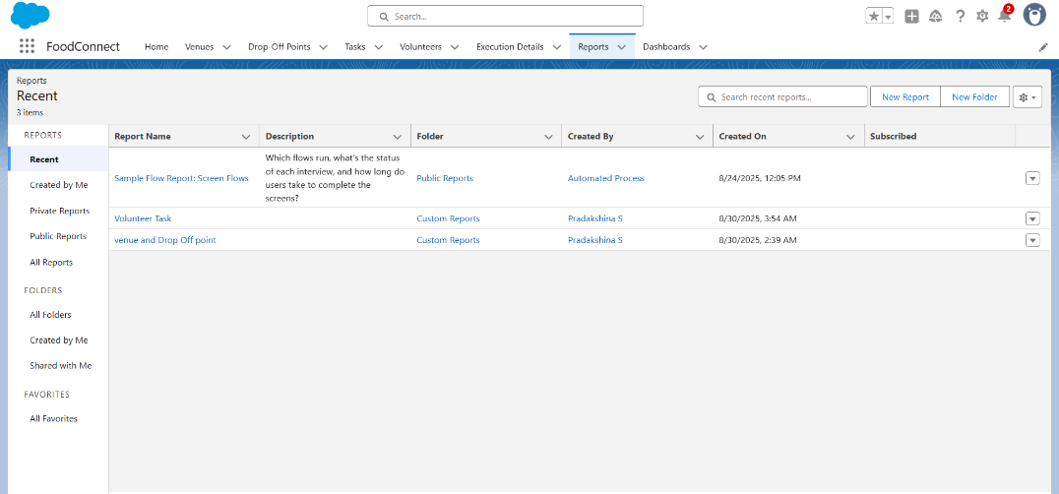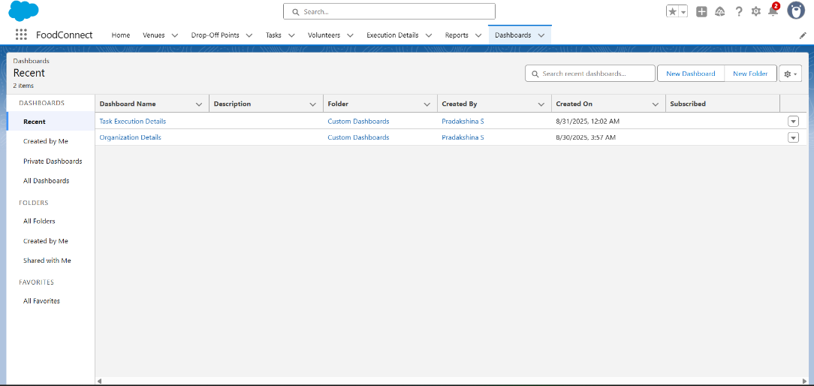

**11. Sharing Rules**

Sharing rules allow NGOs to access records based on distance:

* **Rule 1**: Distance < 15 km → Shared with Iksha Group
* **Rule 2**: Distance between 15–30 km → Shared with NSS Group
* **Rule 3**: Distance between 30–50 km → Shared with Street Cause Group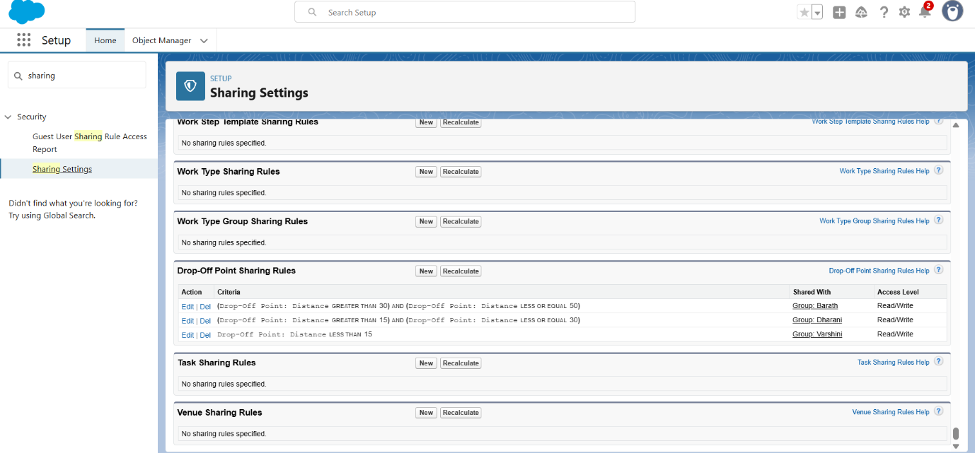

**12. Home Page Customization**

Created a custom **Home Page** using Lightning App Builder:

* Added **Flow (Venue Flow)** for data entry.
* Added **Dashboard** for quick insights.
* Set as **App Default** for Food Connect. 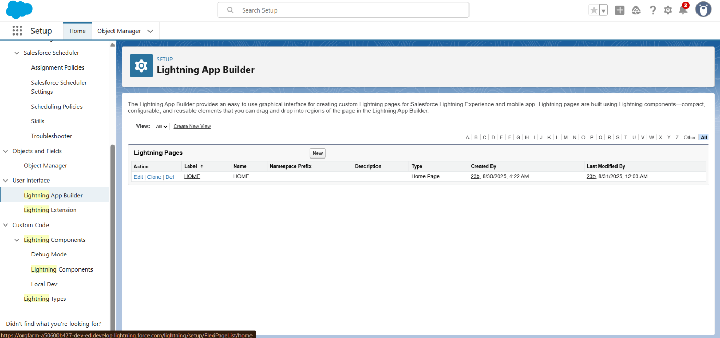

**Conclusion**

This project demonstrates how Salesforce can be configured to:

* Manage venues, drop-off points, volunteers, and tasks.
* Automate data entry using Flows.
* Use Apex Triggers for field updates.
* Control record access using Profiles, Public Groups, and Sharing Rules.
* Create meaningful reports and dashboards for NGOs. 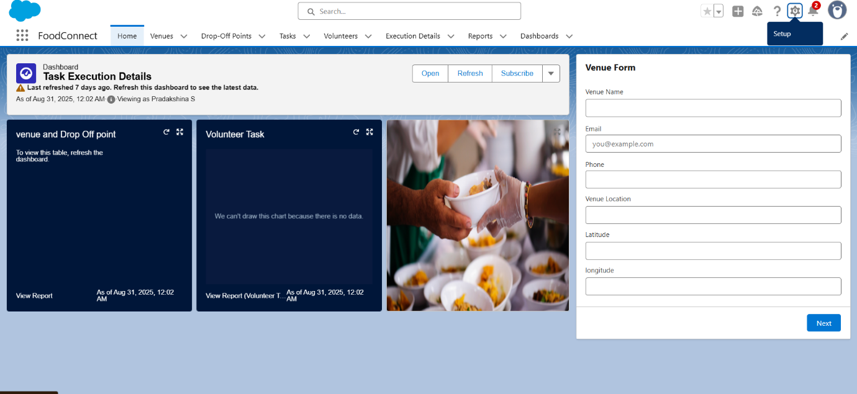

Food Connect serves as a model application showcasing Salesforce's capability to support social organizations in managing logistics, volunteers, and reporting efficiently.